**-----------SETUP GUIDE-----------  
  
1) Open NotePad and copy the following and change the file directory (in red color font) to where the “Jarvis_topurayhan007.py” is located in your PC.**

@echo off

python D:\STUDY\APP\Jarvis_topurayhan007.py %*

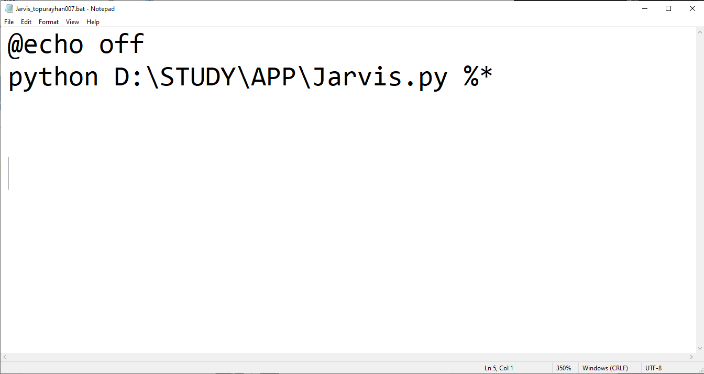

**2) Save the file as “ Jarvis.bat “.**

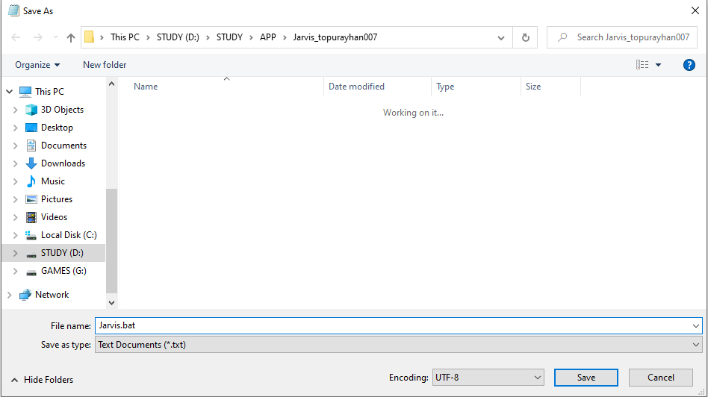

**3) Now press  to open Run.**

**4) Then type “ shell:startup “ and press Enter, startup folder will open.**

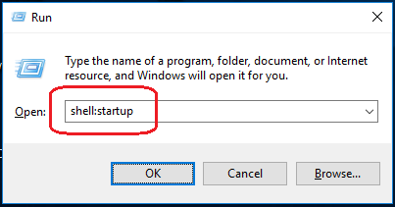

**3) Now just copy the “ Jarvis.bat “ file in the startup folder.**

**4) Walla you are done! 😁**